PRESS RELEASE
No. 140/SP/TKP-ASEAN2023/8/2023
PUBLIC COMMUNICATIONS TEAM

FOR IMMEDIATE RELEASE

ASEAN Tariff Finder Signals Progress in AFTA implementation

Jakarta, Kominfo Newsroom –The Integration in the "ASEAN Tariff Finder" system, which helps regional business actors, signals progress in the implementation of the ASEAN Free Trade Area Agreement (AFTA).
This was stated by Indonesian Trade Minister Zulkifli Hasan, after attending the AFTA Council Meeting as a series of the 55th ASEAN Economic Ministers Meeting, in Semarang, Central Java, Saturday, 19 August 2023.
“The ministers also recorded the ASEAN Tariff Finder. This is a facility for ASEAN business actors to seek information regarding tariffs, this is what we have completed. We will launch it later this afternoon," said Zulkifli.
The use of the ASEAN Tariff Finder, he said, will help businesses actors in Southeast Asia to find the accurate, up-to-date tariff information in one portal.
Integration in the ASEAN Tariff Finder is also expected to help business actors prepare business plans and export-import strategies. It can also reduce risks to business actors, due to a lack of trade and customs information.
Zulhas said that on Saturday afternoon, ASEAN economic ministers, who attended the 55th AEM 2023 in Semarang will launch the "New ASEAN Tariff Finder".
After the AFTA meeting, Zulkifli also held a bilateral meeting with Singapore.
Indonesia and Singapore, said Zulhas, had agreed to set up a working group for an annual trade ministerial level meeting between Indonesia and Singapore.
"I agree bilaterally, because our trade volume with Singapore is quite large and it is necessary, a close neighbour," said Zulkifli. (Indra Arif Ant/TR/Vr)
***
For more information, please contact:
Director General of Public Information and Communications of the Ministry of Communications and Informatics – Usman Kansong (0816785320).
Get more information at http://infopublik.id.

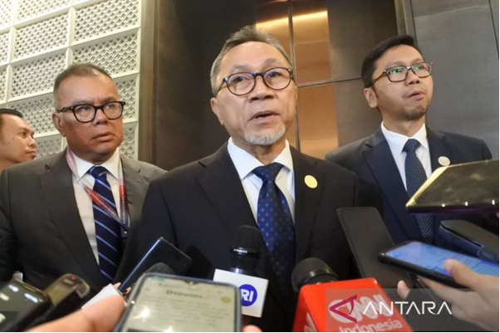
Minister of Trade of Indonesia Zulkifli Hasan speaks to the press after attending the AFTA Council Meeting as part of the 55th ASEAN Economic Ministers (AEM) Meeting in Semarang, Central Java, Saturday, 19 August 2023. ANTARA/Indra Arief Pribadi

